**Problem 1**

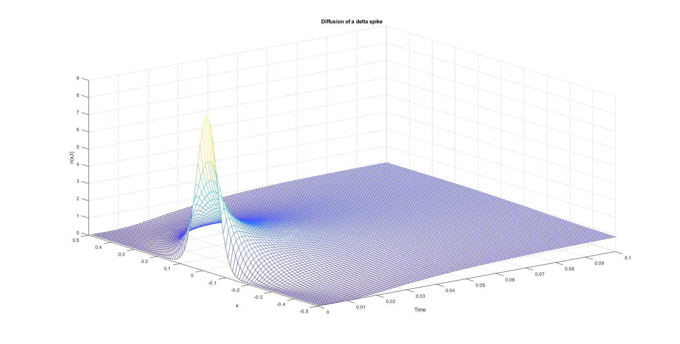





From this figure, it seems the analytical and numerical solutions do not match perfectly.